# Wind Speed Prediction Using RF, XGBoost, and Deep Learning

## Model used – Random Forest

### MODEL SUMMARY

|  |  |
| --- | --- |
| Model Parameters | Values |
| Model Type | Random Forest Regressor |
| n_estimators | 100 |
| Criterion | MSE |
| Max Depth | None |
| Random State | 42 |
| Metrics | R2 Score, MSE |

## Model used – XGBoost

### MODEL SUMMARY

|  |  |
| --- | --- |
| Model Parameters | Values |
| Model Type | XGBoost Regressor |
| n_estimators | 100 |
| Learning Rate | 0.1 |
| Max Depth | 6 |
| Subsample | 0.8 |
| Metrics | R2 Score, MSE |

## Model used – Deep Learning

### MODEL SUMMARY

|  |  |
| --- | --- |
| Model Parameters | Values |
| Model Type | ANN |
| Layers | 3( 256,256,1) |
| Activation Function | ReLU |
| Optimizer | Adam |
| Epochs | 100 |
| Loss | MSE |
| Metrics | R2 Score |

Selected Features (Importance ≥ 0.02): ['latitude', 'longitude', 'd', 'z', 'r', 'q', 'crwc', 't', 'w', 'vo']

🔹 Random Forest:

Time Taken: 25.87 seconds

R² Score: 0.7565699927520787

MSE: 2.3872250657567613

🔹 XGBoost:

Time Taken: 0.47 seconds

R² Score: 0.6475419451453337

MSE: 3.4564214686976142

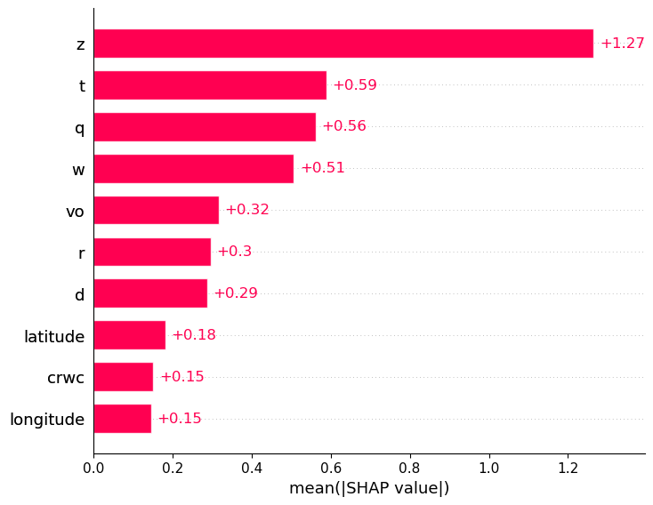

SHAP(Random Forest)

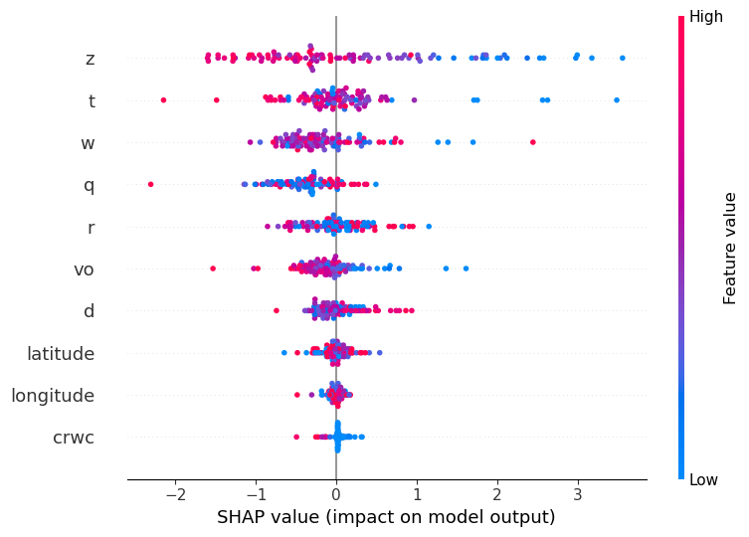

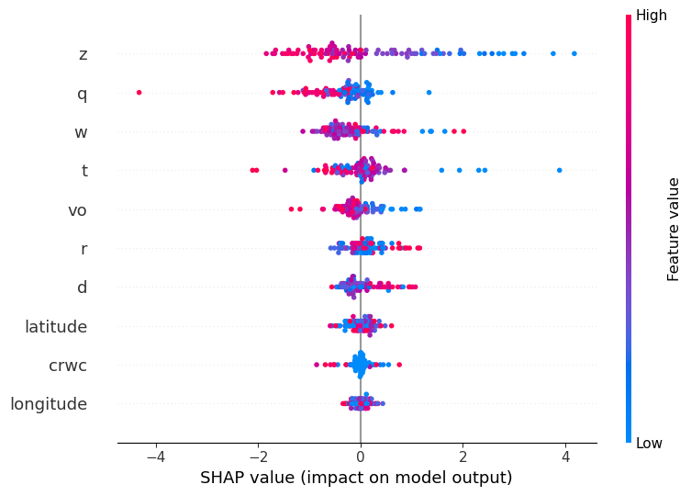

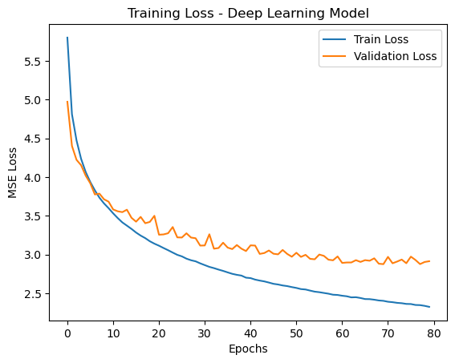

### MODEL SUMMARY

|  |  |
| --- | --- |
| Model Parameters | Values |
| Model Type | ANN |
| Layers | 3( 256,256,1) |
| Activation Function | ReLU |
| Optimizer | Adam |
| Epochs | 100 |
| Loss | MSE |
| Metrics | R2 Score |

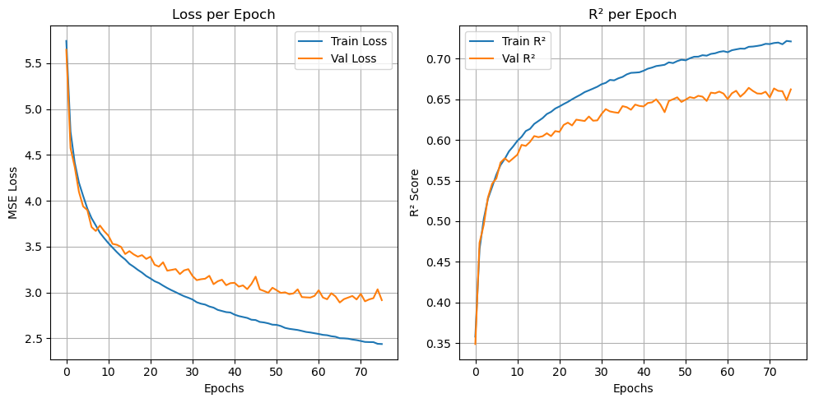

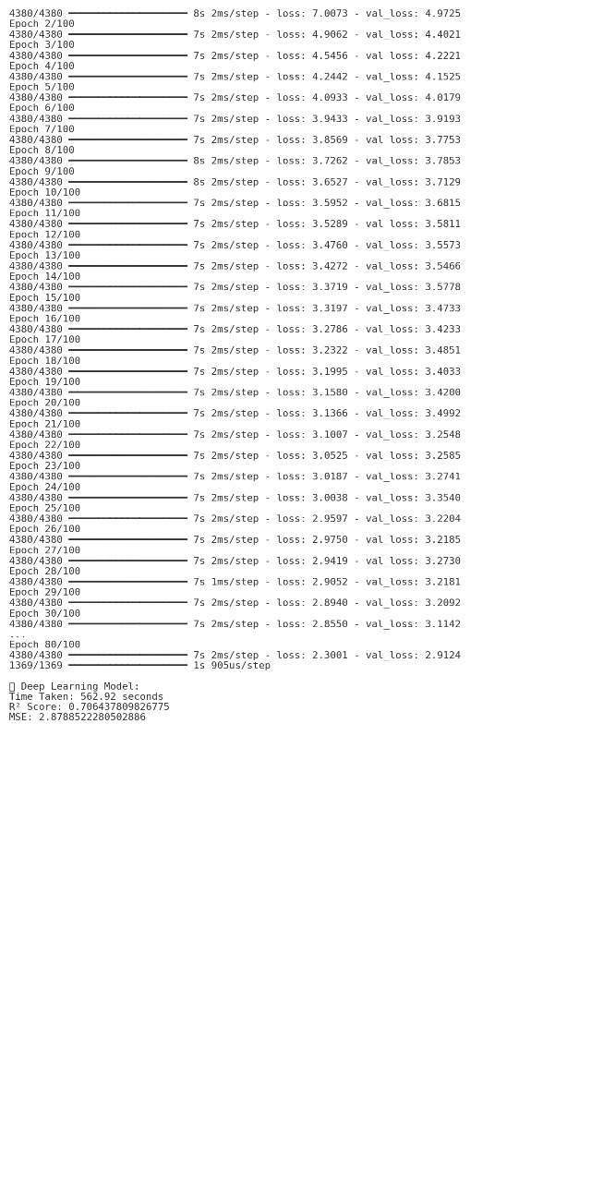

# Update on July 1, 2025

# Model Performance Update and Analysis

## 🔹 Feature Selection

Random Forest's feature importances were used to select features with an importance score ≥ 0.02.   
The selected features were: ['latitude', 'longitude', 'd', 'z', 'r', 'q', 'crwc', 't', 'w', 'vo'].  
These features significantly contributed to improved model performance.

## 🔹 Model Comparisons

### Random Forest (Filtered Features)

- Trained with selected features.  
- Time Taken: 25.87 seconds  
- R² Score: 0.7566  
- MSE: 2.3872  
Feature selection improved both accuracy and training efficiency.

### XGBoost (Filtered Features)

- Used same selected features.  
- Time Taken: 0.47 seconds  
- R² Score: 0.6475  
- MSE: 3.4564  
XGBoost performed faster but slightly underperformed in accuracy compared to Random Forest.

## SHAP Analysis

SHAP (SHapley Additive exPlanations) values were used to interpret feature contributions for Random Forest and XGBoost models.   
They provide insight into the influence of each feature in the prediction process.

# Models Used : DL Models

### MODEL SUMMARY

|  |  |
| --- | --- |
| Model Parameters | Values |
| Model Type | ANN |
| Layers | 5 (256, 256, 128, 64,1) |
| Activation Function | ReLU |
| Optimizer | Adam |
| Epochs | 100 |
| Loss | MSE |
| Metrics | R2 Score |

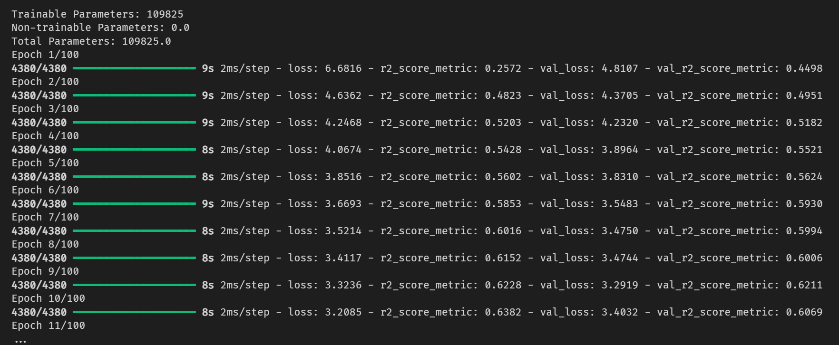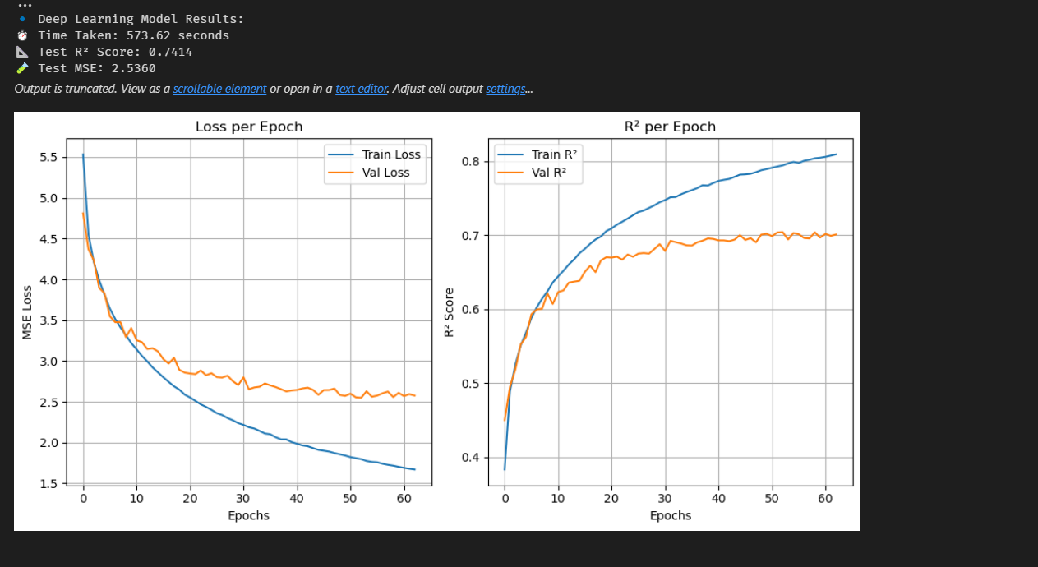

## Random Search

### MODEL SUMMARY

|  |  |
| --- | --- |
| Model Parameters | Values |
| Model Type | ANN |
| Layers | 4 (1,2,3,4) |
| Activation Function | ReLU |
| Optimizer | Adam, RMS prop, sgd |
| Epochs | 100 |
| Loss | MSE |
| Metrics | R2 Score |

